Daniel Tarr

William Blake : The Book of Urizen

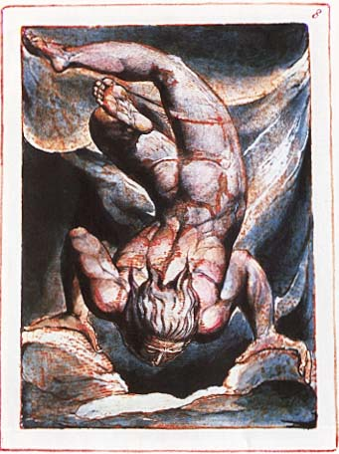

ELTE BTK
DEPARTMENT OF ENGLISH LITERATURE AND LINGUISTICS
Thesis
2000.

Table of Contents
Acknowledgement……………………………………………………………………2.
Introduction…………………………………………………………………………….3.
I. Introducing William Blake………………………………………………..4-25.
II. Major Influences……………………………………………………………26-42.
The Romantic period………………………………………………….26-28.
- The Poets of Early-Romanticism…………………………...28-30.
Mysticism and Romanticism………………………………………30-31.
- Protestant mysticism……………………………………….31-33.
- Political radicalism……………………………………….…33-36.
- Neoplatonism………………………………………………...36-37.
- Freemasonry and Secret Societies………………………37-39.
- The New Church…………………………………………….39-42.
III. The Book of Urizen………………………………………………………43-47.
The Chapters……………………………………………………………...48-72.
- Preludium …………………………………………………...48-50.
- Chapter 1. - Urizen……………………….…………….50-52.
- Chapter 1I. – Prior to Existence……….………..53-56.
- Chapter 1II. – Grasping Subsistence……….…….57-59.
- Chapter 1V. – Taking Form……….………………59-62.
- Chapter V. – Foundations of Life……….……..63-65.
- Chapter VI. – Generation……….…………………..65-67.
- Chapter VII. – Chains of Being……….…………..67-78.
- Chapter VIII. – The Material World………69-71.
- Chapter 1X. – The Human Race……….………..71-72.

Appendix: William Blake – The Book of Urizen……………….73-84.
Bibliography………………………………………………………………………..85-88.
List of Plates……………………………………………………………………….…...89.

